Prompt & RAG Experimentation Framework
Contoso Health System (CHS) — Clinical Knowledge Assistant
Prepared by Dennis (GenAIOps Engineer), version 1.0, 12 October 2026. Audience: engineering, clinical SMEs, compliance.

1. Purpose, Scope and Environment Tags
This framework governs how prompt and RAG changes to the CHS Clinical Knowledge Assistant are proposed, tested, approved, promoted and rolled back. Every production answer traces to a release tuple (prompt, index, embedding and model versions), and every promotion is reconstructable from the audit trail. Environment values appear as {{TAGS}}, resolved per environment from Key Vault {{KEYVAULT_URI}} and a pinned lockfile.
Tag | Resolves to | Used for
{{FOUNDRY_PROJECT_ENDPOINT}} | https://<resource>.services.ai.azure.com/api/projects/<project> | Evaluation runs; judge model {{JUDGE_DEPLOYMENT}}
{{AOAI_ENDPOINT}} | Foundry model inference | Generation and embeddings
{{SEARCH_ENDPOINT}} | https://<service>.search.windows.net | Per-domain indices, release aliases
{{LANGUAGE_ENDPOINT}} | Azure AI Language PII detection (PHI domain) | PHI scans
{{AUDIT_STORAGE_ENDPOINT}} | Immutable (WORM) blob container | Audit records
{{APPINSIGHTS_CONNECTION}} | Application Insights | Telemetry, drift alerts
{{SDK_AI_EVALUATION}}, {{SDK_AI_PROJECTS}}, {{SDK_SEARCH}}, {{SDK_OPENAI}}, {{SDK_IDENTITY}}, {{SDK_TEXTANALYTICS}} | Pinned versions of azure-ai-evaluation, azure-ai-projects, azure-search-documents, openai, azure-identity, azure-ai-textanalytics | Reproducible runs; upgrades are change-controlled
Table 1. Environment tags (Entra ID principal tags: Table 9).

2. Risk Classification Rules
Tiers use the scenario brief’s names verbatim and drive every gate, threshold and SLA:
- Critical: output can directly change a medication decision.
- Medium-High: output guides clinical action a clinician reviews first, or is patient-facing.
- Low: no direct clinical consequence.
- Highest tier wins: anything spanning tiers takes the highest (a leaflet mentioning an interaction is Critical); shared components inherit the highest tier they feed.
- Most restrictive state: content must satisfy the strictest of the five state pharmacy boards.
Use case | Code | Tier | Gate | Primary reviewer
Drug-interaction checks | DDI | Critical | GATE-CRITICAL-v1 | Pharmacy SME + Clinical Safety Officer
Protocol lookup | PRO | Medium-High | GATE-MEDHIGH-v1 | Specialty-matched Clinical SME
Patient education generation | PED | Medium-High | GATE-MEDHIGH-v1 + readability | Clinical SME + Health Literacy reviewer
Administrative guidance | ADM | Low | GATE-LOW-v1 | Departmental owner (spot-check)
Table 2. Use-case risk classification.

3. PromptOps Governance Policy

3.1 Versioning and naming
- Prompts: PMT-{DOMAIN}-{NNN} with SemVer, e.g. PMT-DDI-004 v2.1.0. MAJOR = clinical instruction, safety rule or output format; MINOR = wording or examples; PATCH = formatting. A MAJOR change resets SME approval.
- Embeddings and indices: EMB-{model}-{ver} and IDX-{DOMAIN}-{EMB}-{CHUNK}-{YYYYMMDD}, e.g. IDX-DDI-modelB-v2-SEM15-20261101. Production reaches an index only through its release alias (ddi-prod).
- Experiments: EXP-{YYYY}-{NNNN}, one manifest each. Prompts and manifests live in Git, not application code.

3.2 Change control and approval gates
Every change needs a manifest, a change-control ticket and two-person pull-request review. SME and compliance approvals are required-reviewer approvals on the {{ENV_PROD_APPROVAL}} environment, and gates fail closed: an expired SLA escalates, never auto-approves.
Tier | Approvals before any production exposure | Exposure path
Critical | Automated gate + Pharmacy SME (Clinical Safety Officer on escalation) + Compliance | Shadow only after pharmacist sign-off, then staged
Medium-High | Automated gate + specialty SME (+ Health Literacy for PED) + Compliance | Shadow during review, then staged
Low | Automated gate alone; departmental owner spot-checks weekly | Staged
Table 3. Approval gates. Staged rollout: one site, one region, then all 12 hospitals, each after a clean monitoring window.
Critical changes enter shadow mode only after pharmacist sign-off, because the brief counts shadow mode as production exposure; the supplied workflow placed it before review. Emergency formulary recalls get an expedited pharmacy re-index but keep the Critical gate.

3.3 Authoring standards and PHI minimization
- No PHI in prompts, examples, logs or evaluation datasets; datasets are synthetic or de-identified (HIPAA Safe Harbor), PHI-scanned via {{LANGUAGE_ENDPOINT}} before snapshotting, and exclude 42 CFR Part 2 content.
- Clinical prompts are cite-or-abstain: answer only from retrieved passages with the passage ID, otherwise state “not found in approved sources” and refer onward.
- Responses carry a decision-support disclaimer; PED output targets a grade 6–8 reading level.
- Query logs hash user IDs and redact free text; retention follows compliance policy.

3.4 Required healthcare metadata
Group | Fields (manifest and audit record)
Identity | experiment_id, use_case, clinical_risk_tier, prompt_id, semantic_version, author, change_control_ticket
Clinical provenance | source_corpus_version, formulary_effective_date, states_validated, regulatory_refs (HIPAA, 42 CFR Part 2, state boards, FDA labeling)
Privacy | phi_attestation, phi_scan_result, dataset_snapshot_id
Approval and audit | gate_thresholds_ref, automated_gate_result, sme_approver_id, sme_decision + timestamp, compliance_approver_id, audit_token, retention_policy
Rollback | rollback_target (last known-good release tuple), rollback_flag, rollback_reason
Table 4. Required metadata. Bold fields extend the supplied manifest skeleton.

3.5 Rollback triggers
Tier | Incident triggers | Owner | SLA | Review
Critical | Groundedness below 4.6 for 2 consecutive monitoring windows; any clinician-reported interaction error | GenAIOps on-call; Clinical Safety Officer notified | 30 min | 5 days
Medium-High | Groundedness below 4.25 for 3 consecutive windows; clinician-reported inaccurate protocol guidance | GenAIOps on-call | 120 min | 5 days
Low | 3+ user-reported factual errors per week | GenAIOps on-call | 480 min | 10 days
Table 5. Rollback triggers and SLAs.
Rollback repoints the affected domain’s release alias to rollback_target; domain-segmented indices mean a pharmacy rollback leaves other domains untouched. On-call engineers activate the deploy permission just-in-time through Privileged Identity Management, and each rollback is audited.

4. RAG Experiment Matrix
Each experiment changes one dimension against the production baseline, offline, on a frozen PHI-free dataset. Priority weighs expected impact against the safety cost of a regression; P1 runs first.
ID | Dimension | Variants (baseline first) | Scope | Impact | Safety risk | Priority
R1 | Chunking: drug monographs | Fixed 512 tokens/10% overlap vs. interaction-atomic (one drug pair per chunk) | DDI | High | Critical | P1
R2 | Chunking: protocols | Fixed 512/10% vs. semantic, heading-aware, 15% overlap | PRO | High | Medium-High | P1
R3 | Retrieval mode | Dense vs. hybrid dense + BM25 (exact drug names, doses) | DDI, PRO | High | Critical | P1
R4 | Prompt grounding | Cite-or-abstain v1 vs. v2 (stricter refusal) | DDI, PRO | High | Critical | P1
R5 | Embedding model | modelA-v1 vs. modelB-v2 (full re-index per domain) | All | High | Critical | P2
R6 | Retrieval depth | top_k 3 / 5 / 8 with reranker-threshold sweep | All | Medium | Medium-High | P2
R7 | Context window | 4k vs. 8k tokens of retrieved context | PRO, PED | Medium | Medium-High | P2
R8 | Readability prompt | Grade 8 vs. grade 6 instruction | PED | Medium | Medium-High | P2
R9 | Index strategy | Per-domain vs. unified (offline only: unified loses independent freshness and rollback) | All | Low | Critical | P3
Table 6. RAG experiment matrix.

4.1 Reproducibility checklist
- Manifest committed and linked to its ticket before the run.
- Immutable, PHI-scanned dataset_snapshot_id; fixed random_seed; temperature 0 for evaluation runs.
- Pinned judge model (evaluator_model_version); evaluators run three times and are averaged to absorb judge variance.
- SDK versions from lockfile tags; chunker commit SHA, index, embedding and formulary versions recorded.
- Rerunning from the manifest alone reproduces gate scores within ±0.1; raw outputs stored in {{AUDIT_STORAGE_ENDPOINT}}.

5. Evaluation Framework

5.1 Metrics and automated gates
The runner calls azure-ai-evaluation ({{SDK_AI_EVALUATION}}) against {{FOUNDRY_PROJECT_ENDPOINT}}, scoring on the native 1–5 scale with gates from evaluation_gates.yaml.
Use case | Gate | Quality thresholds (1–5) | Safety and domain checks | On fail
DDI | GATE-CRITICAL-v1 | Groundedness ≥4.6 (mean and every response); relevance ≥4.3; retrieval ≥4.2 | Content safety: any flag; drug_interaction_accuracy: 0 missed, 0 fabricated; PHI leak: 0 | Block
PRO | GATE-MEDHIGH-v1 | Groundedness ≥4.25; relevance ≥4.0; coherence ≥3.8; completeness ≥3.8 (preview, provisional) | Content safety; citation present; PHI leak: 0 | Hold for SME
PED | GATE-MEDHIGH-v1 | As PRO | As PRO, plus readability grade ≤8 (custom) | Hold for SME
ADM | GATE-LOW-v1 | Relevance ≥3.6; fluency ≥3.6 | Content safety; PHI leak: 0 | Block
Table 7. Metrics by use case. Content safety and PHI checks run at every tier (extends the sample YAML).
Built-in groundedness checks support by retrieved context, not pharmacological correctness: a stale monograph can be perfectly “grounded”. Hence the SME-curated drug_interaction_accuracy evaluator blocks independently, and R1 and R3 also require labelled recall@k of 1.0 on known interaction pairs.

5.2 Human-in-the-loop triggers and SLAs
Tier | Triggers | Reviewer | SLA | Action
Critical | Any safety flag or custom-evaluator failure; any response below 4.6 groundedness; drug entity unseen in 90 days of evaluation sets | Pharmacy SME; Clinical Safety Officer escalation | 4 h | Pause promotion; page via {{PAGING_SYSTEM}}
Medium-High | Any evaluator below threshold; groundedness drift above 0.3 vs. 30-day production baseline | Specialty SME or Health Literacy reviewer | 24 h | Hold in shadow; queue
Low | Gate failure in 3 or more consecutive runs | Departmental owner | 48 h | Weekly spot-check
Table 8. Review triggers. A missed SLA escalates one level and the change stays blocked.

5.3 Production monitoring
Continuous evaluation reruns each tier’s evaluators on PHI-scrubbed production samples every monitoring window; {{APPINSIGHTS_CONNECTION}} alerts implement the Section 3.5 triggers. A freshness guard switches drug-interaction answers to abstain-and-refer whenever the pharmacy index lags the licensed formulary, until re-indexing passes the Critical gate. Clinician error reports feed review queues and rollback counts.

6. Experimentation Workflow and Roles
Figure 1 (next page) traces an experiment through callouts 1–10. Gate failures and SME rejections return to engineering as a new version in the same experiment lineage; production incidents trigger rollback, and every decision is written to the audit trail.
Role | Principal tag | Entra ID role assignments (scope) | Callouts
GenAIOps engineers | {{GRP_GENAIOPS}} | Foundry User (dev/test); Search Index Data Contributor (dev indices); Reader (prod) | 1, 2, refine
Evaluation runner | {{MI_EVAL_RUNNER}} | Foundry User (eval project); Search Index Data Reader; Storage Blob Data Contributor (audit) | 3, 10
Clinical SMEs | {{GRP_PHARM_SME}} {{GRP_CLIN_SME}} | No data-plane roles; required reviewers on {{ENV_PROD_APPROVAL}} | 5
Compliance and privacy | {{GRP_COMPLIANCE}} | Reader; Log Analytics Reader; required reviewer | 6
Deployment pipeline | {{MI_DEPLOY}} | Search Index Data Contributor (prod); only principal that repoints aliases | 7
GenAIOps on-call | {{GRP_ONCALL}} | PIM-eligible, time-bound deploy role | 9
Assistant runtime | {{MI_APP_RUNTIME}} | Foundry User; Search Index Data Reader (read-only) | 8
Audit owner | {{GRP_AUDIT}} | Storage Blob Data Reader (audit); Log Analytics Reader | 10
Table 9. Roles and Entra ID assignments (Foundry User was formerly named Azure AI User).

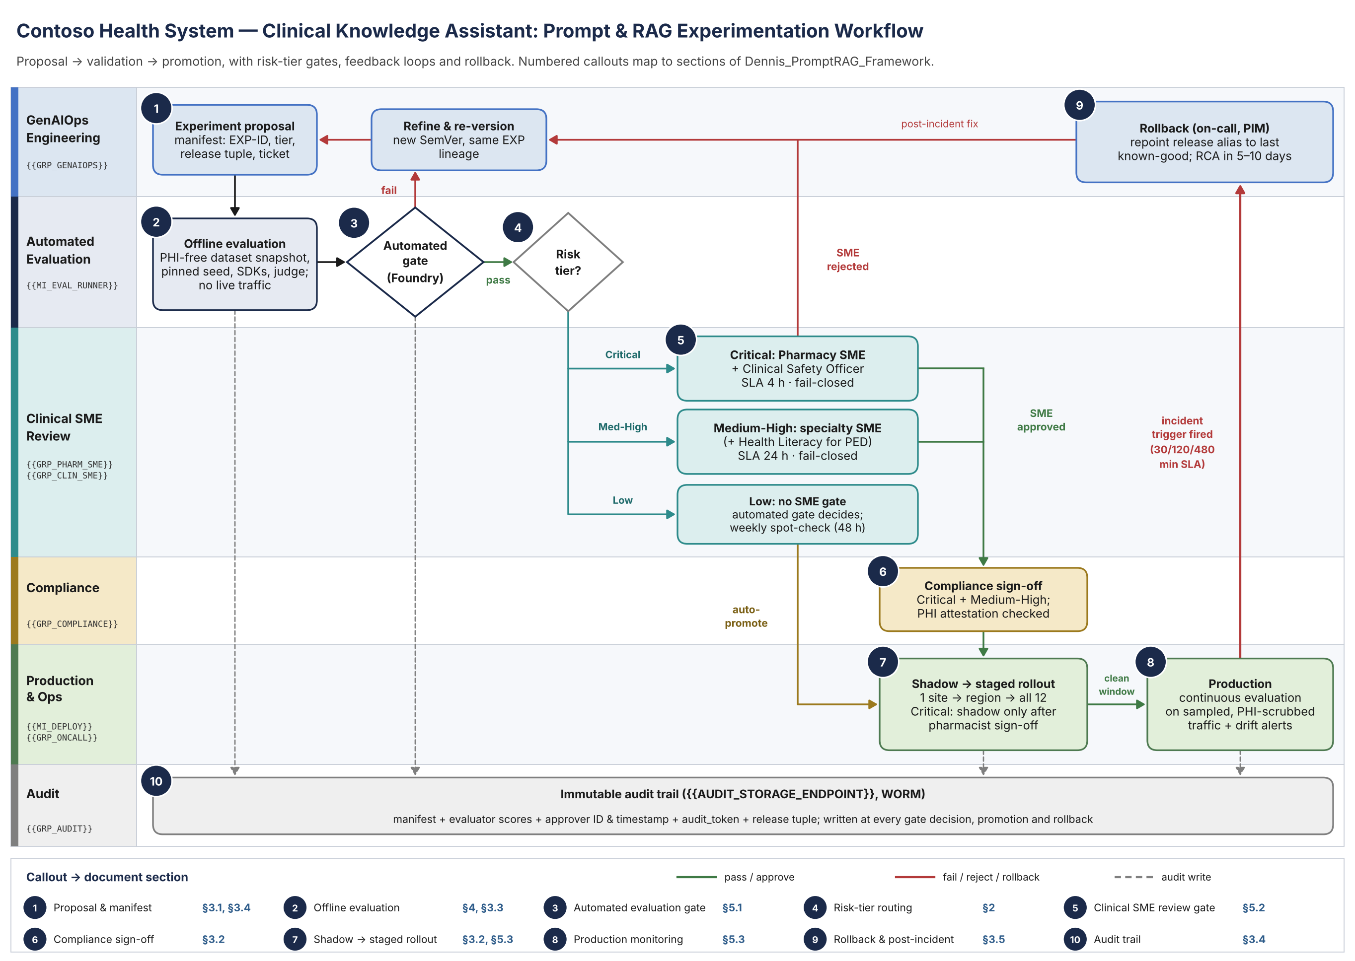
Figure 1. Experimentation workflow; numbered callouts map to document sections (also supplied as Dennis_PromptRAG_Diagram.pdf/.png).

